Task 8
Operating system (lab)
Name :Nabiha Sabir
Roll no: su92-bssem-s24-019
Section :4A
Subject :operating system (lab)

Task 1: Modify Peterson’s Algorithm to handle synchronization for 3 processes instead of 2. Hint: Use a flag list and a turn variable (or list) to control access between all three processes.
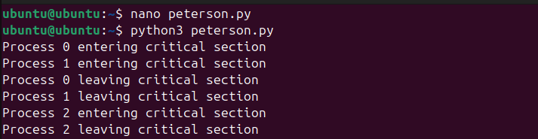
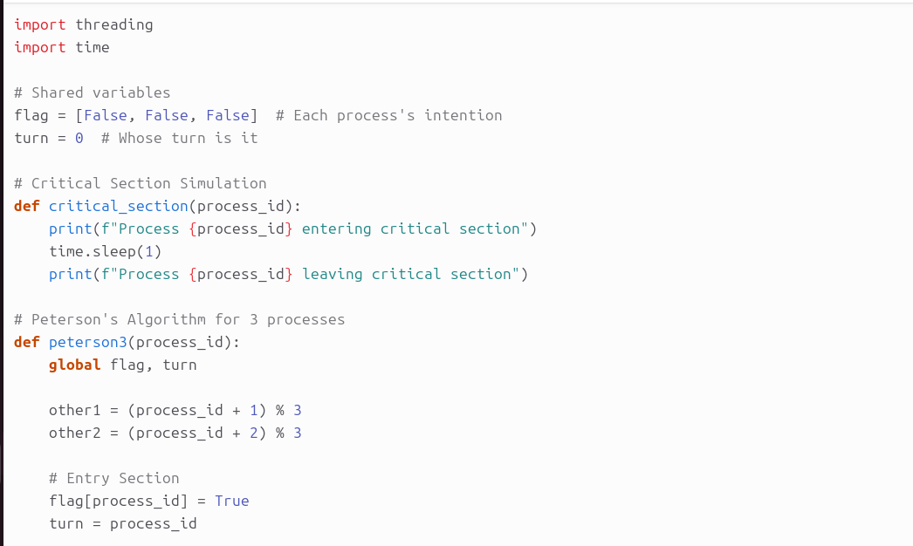
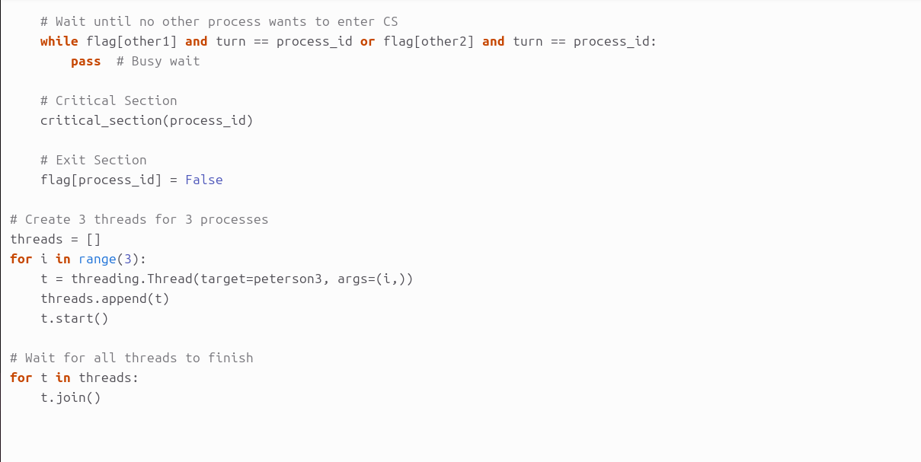
Task 2: Create a banking system using semaphores where 3 threads modify a shared account balance. Make sure that the balance never becomes negative even when multiple threads try to withdraw or deposit money at the same time.

import threading
import time
import random

# Shared bank account balance
balance = 1000 # Initial balance

# Semaphore to control access to shared balance
sem = threading.Semaphore(1)

# Function for a thread to deposit or withdraw
def transaction(thread_id):
global balance

for _ in range(5): # Each thread does 5 transactions
action = random.choice(["deposit", "withdraw"])
amount = random.randint(100, 500)

sem.acquire() # Enter critical section
if action == "withdraw":
if balance >= amount:
print(f"Thread {thread_id} withdrawing {amount}")
balance -= amount
else:
print(f"Thread {thread_id} tried to withdraw {amount} but insufficient balance")
else: # deposit
print(f"Thread {thread_id} depositing {amount}")
balance += amount
print(f"Balance after thread {thread_id}'s transaction: {balance}\n")
sem.release() # Exit critical section

time.sleep(random.uniform(0.1, 0.5)) # Simulate delay

# Create 3 threads
threads = []
for i in range(3):
t = threading.Thread(target=transaction, args=(i,))
threads.append(t)
t.start()

# Wait for all threads to finish
for t in threads:
t.join()

print(f"Final balance: {balance}")
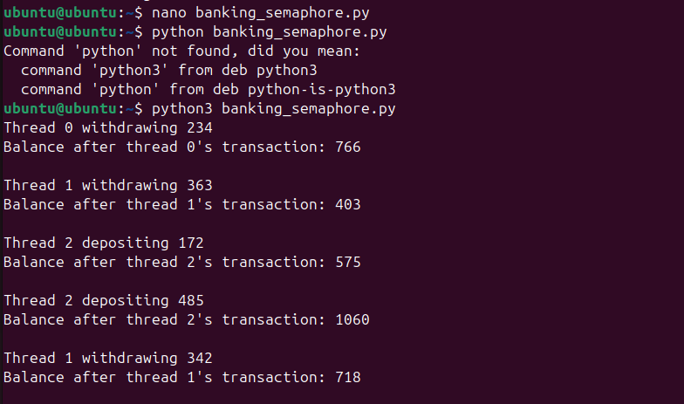

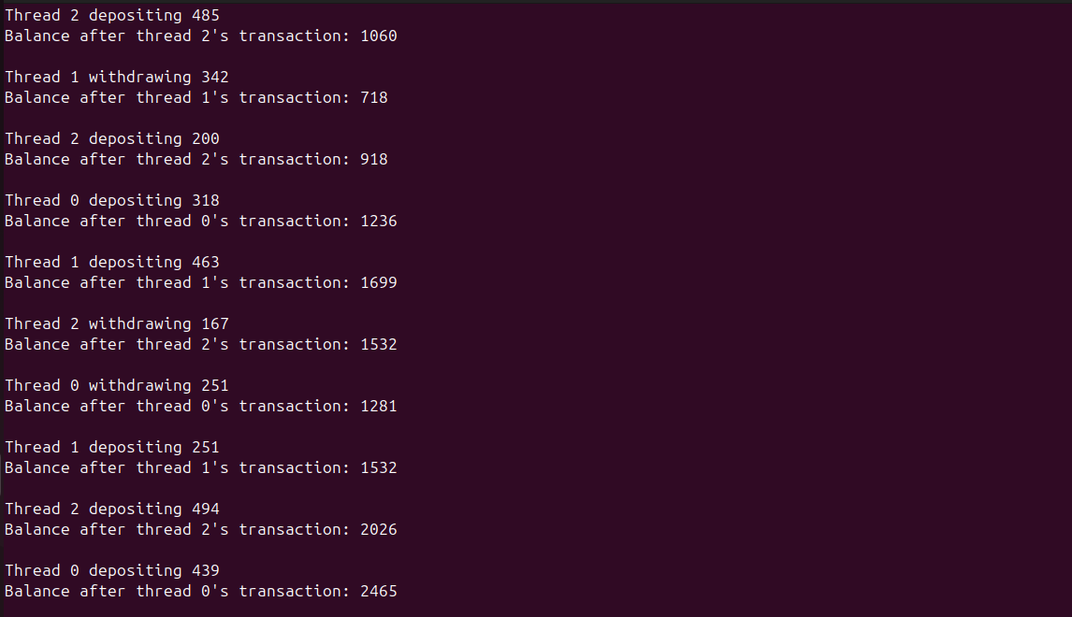

Task 3: Simulate a printing system where 5 students share a single printer. Use a binary semaphore to control access so that only one student can print at a time.
import threading
import time
import random

# Binary semaphore for the printer
printer = threading.Semaphore(1)

# Function for a student trying to print
def student_print(student_id):
print(f"Student {student_id} wants to print")

# Acquire printer (critical section)
printer.acquire()
print(f"Student {student_id} is printing...")
time.sleep(random.uniform(1, 3)) # Simulate printing time
print(f"Student {student_id} finished printing\n")

# Release printer
printer.release()

# Create 5 student threads
threads = []
for i in range(1, 6):
t = threading.Thread(target=student_print, args=(i,))
threads.append(t)
t.start()

# Wait for all threads to finish
for t in threads:
t.join()

print("All students have finished printing.")
